How To Do an Elevation Survey
With a focus on Water Systems
[DRAFT] 12/6/200 Art Ludwig
7/1/2008 updated

What Use is an Elevation Survey?
Elevations are of primary importance in the design and construction of water and wastewater systems, including the siting of storage inlets, outlets, overflows and drains, laying out of water lines, and determining the optimum relationship between water supply and use features.
Elevations can also be useful for laying out roads and trails,

The more accurately elevations are known, the closer your water system can be built to the theoretical optimum. For example, with the height of a spring accurately known, and a pipe laid out with precise slope to a storage tank, the tank can be located higher on your land so you can serve more area with better pressure.

Sample Survey

Elevation Tables, Elevation View Drawings
Elevation view drawings are an extremely helpful, yet underutilized tool for visualizing, understanding, and optimizing elevation relationships between system elements.
An elevation overview drawing shows the height of all system elements on one sheet, with a vertical scale. Some may also be to scale horizontally. In the case of a site with system elements scattered all over the land (as opposed to being in a line) the vertical scale is maintained exact while the horizontal location of the elements is only loosely tied to reality.
The first step to making an elevation view drawing is a table of elevations.

Survey record v. 2.0 © 2007 Oasis Design
Date:
Weather
 | Out | Out |  | Back | Back
Time | Altitude | Dist | Location | Altitude | Dist
hrs:min | ft/m | paces/ft/m

Using the automatic graph function in Excel you can turn a table directly into elevation view graphs/ drawing (blue line is existing pipeline, bars are system elements…sorry about the Spanish—this will get translated in a later edition)

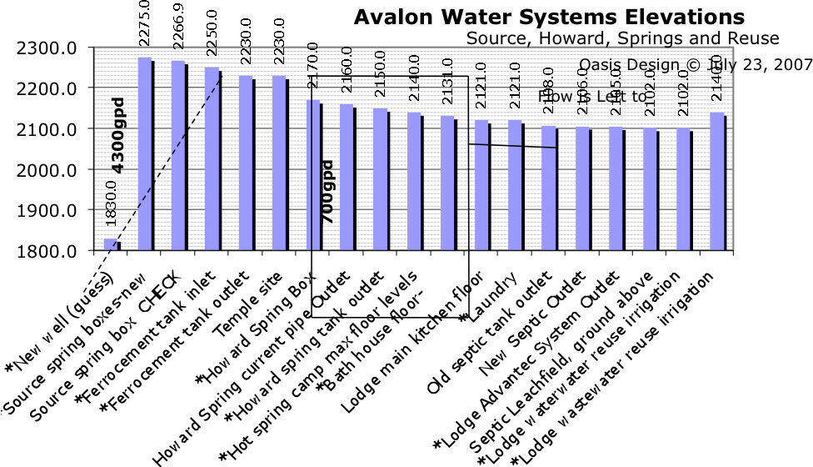
For a small system, one drawing could show both the elevation of a spring relative to a tank, say, as well as the heights of the inlets, outlets, overflows, and drains of the spring box and tank.
For a system that has elements widely separated in elevation, or small, critical elevation relationships, it may be best to do one overview drawing at a scale that enables everything to fit on one sheet, with “zoomed in” drawings of individual elements.

Ways of Measuring Elevations

Tape Measure

Precision: 1/32”/ 1mm
If the thing you’re measuring is small enough and straight up and down enough, you can just measure off heights with a tape measure. If it slanted, you can use a level and tape measure

Pressure Guage

Precision: Depends on the guage; can be 1” or less for high-precision guages (which will have the precision marked on the face) otherwise a few to several feet
If there is a leak free pipe that has a continous water column from the level of the gauge to the water level in a tank or spring, you can read the psi off the gauge and divide by 2.3604 to get feet (at sea level).

Altimeter
Barometric Altimeters can measure the height of widely seperated points that are hidden from eachother by by vegetation or folds of earth. They do not require line of sight, and are not affected by the earth’s curvature over long distances.
With careful technique, they can be accurate to ±3 feet (1m).

Modern digital barometric altimeters are yet another advanced technology that is indistinguishable from magic.
They read the weight of the column of air pressing on them from above with an electronic load cell.

Getting approximate results
Getting approximate elevations is really easy. Just read off the elevation at the points of interest. If you go back to the first point after checking the last one, you can get a general
Idea of how much the pressure has changed.

GPS
GPS are reputed to be poor for elevations but this may be changing. They are great for coordinates.

Water Level, Water Transit, Abney Level, Transit
See Create an Oasis with Greywater, Appendix B

Google Earth
From directly above, zoom in until your water system elements fill the whole screen. Hover over a point of interest and it will give you an elevation (who knows how accurate; probably varies a lot).
Click on “Tools/Ruler/Path” and then click on the start of your water line. Click on each way point, and note the elevations as you go. On the last click, record the length of line and its location in the topography by saving the screen as a jpeg—not super accurate, but considering you can do it from the comfort of your armchair halfway around the world, as compared to on the ground with sweat, mosquitos and a machete, not bad at all…

